Bird monitoring trip report

Michelle Hall, Angela Recalde-Salas & Justin McCann

26 Dec 2023

Table of Contents

# Results of 2023 bird monitoring at Charles Darwin Reserve

## Bird counts and species detected

We surveyed the bird community at Charles Darwin Reserve in 2023, detecting a total of 976 birds of 63 species in 7 Conservation Targets (Figure 1, Table 1 & 2). We conducted 54 surveys of 34 sites from 23 Sep 2023 to 27 Sep 2023. Table 3 summarises birds detected by survey method and observer.

**Figure 1. Number of species detected in Conservation Targets.** Plot shows variation in the number of species detected per survey across different Conservation Targets. Each point shows the result of one survey. Boxes enclose the middle 50% of the data (inter-quartile range).

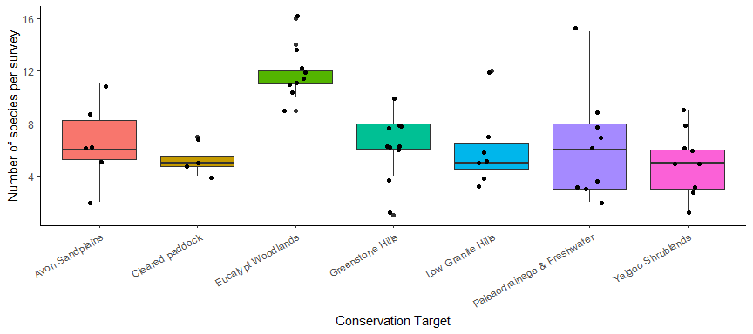

**Table 1. Survey summary.** Distribution of bird detections across Conservation Targets.

| Conservation Target | nBirds | nSites | nSurveys |
| --- | --- | --- | --- |
| Avon Sandplains | 69 | 5 | 6 |
| Cleared paddock | 93 | 2 | 4 |
| Eucalypt Woodlands | 205 | 7 | 9 |
| Greenstone Hills | 225 | 5 | 10 |
| Low Granite Hills | 92 | 5 | 7 |
| Paleaodrainage & Freshwater | 186 | 5 | 9 |
| Yalgoo Shrublands | 106 | 5 | 9 |

**Table 2. Charles Darwin Reserve species list for 2023.** Species list showing the number of birds detected, and the number of Conservation Targets, sites and surveys they were detected in.

| Species | Scientific Name | Count | nTargets | nSites | nSurveys |
| --- | --- | --- | --- | --- | --- |
| Australian Hobby | Falco longipennis | 1 | 1 | 1 | 1 |
| Australian Magpie | Cracticus tibicen | 5 | 2 | 2 | 2 |
| Australian Pipit | Anthus novaeseelandiae | 2 | 1 | 1 | 1 |
| Australian Raven | Corvus coronoides | 6 | 3 | 5 | 5 |
| Australian Ringneck | Barnardius zonarius | 37 | 7 | 15 | 17 |
| Banded Lapwing | Vanellus tricolor | 1 | 1 | 1 | 1 |
| Black Honeyeater | Sugomel niger | 1 | 1 | 1 | 1 |
| Black-breasted Buzzard | Hamirostra melanosternon | 4 | 2 | 2 | 3 |
| Black-faced Cuckoo-shrike | Coracina novaehollandiae | 10 | 4 | 7 | 7 |
| Bourke's Parrot | Neopsephotus bourkii | 4 | 1 | 1 | 1 |
| Brown Falcon | Falco berigora | 6 | 3 | 3 | 3 |
| Brown Honeyeater | Lichmera indistincta | 1 | 1 | 1 | 1 |
| Chestnut-rumped Thornbill | Acanthiza uropygialis | 45 | 6 | 12 | 12 |
| Common Bronzewing | Phaps chalcoptera | 3 | 1 | 3 | 3 |
| Crested Bellbird | Oreoica gutturalis | 15 | 5 | 10 | 11 |
| Crested Pigeon | Ocyphaps lophotes | 6 | 1 | 1 | 2 |
| Emu | Dromaius novaehollandiae | 1 | 1 | 1 | 1 |
| Galah | Eolophus roseicapillus | 13 | 5 | 8 | 10 |
| Grey Butcherbird | Cracticus torquatus | 14 | 5 | 10 | 11 |
| Grey Currawong | Strepera versicolor | 11 | 5 | 6 | 7 |
| Grey Fantail | Rhipidura albiscapa | 4 | 1 | 3 | 3 |
| Grey Shrike-thrush | Colluricincla harmonica | 25 | 5 | 17 | 17 |
| Grey-fronted Honeyeater | Lichenostomus plumulus | 3 | 1 | 1 | 2 |
| Horsfield's Bronze-Cuckoo | Chalcites basalis | 1 | 1 | 1 | 1 |
| Inland Thornbill | Acanthiza apicalis | 27 | 6 | 13 | 14 |
| Jacky Winter | Microeca fascinans | 2 | 1 | 1 | 1 |
| Little Corella | Cacatua sanguinea | 7 | 1 | 1 | 1 |
| Major Mitchell's Cockatoo | Lophochroa leadbeateri | 7 | 2 | 2 | 3 |
| Masked Woodswallow | Artamus personatus | 1 | 1 | 1 | 1 |
| Mulga Parrot | Psephotus varius | 14 | 2 | 3 | 3 |
| Nankeen Kestrel | Falco cenchroides | 6 | 2 | 2 | 3 |
| Pied Butcherbird | Cracticus nigrogularis | 6 | 1 | 4 | 5 |
| Red Wattlebird | Anthochaera carunculata | 3 | 2 | 3 | 3 |
| Red-capped Robin | Petroica goodenovii | 20 | 5 | 8 | 9 |
| Red-tailed Black-Cockatoo | Calyptorhynchus banksii | 7 | 3 | 3 | 3 |
| Redthroat | Pyrrholaemus brunneus | 20 | 5 | 12 | 14 |
| Rufous Treecreeper | Climacteris rufa | 6 | 2 | 5 | 5 |
| Rufous Whistler | Pachycephala rufiventris | 27 | 6 | 16 | 18 |
| Singing Honeyeater | Lichenostomus virescens | 21 | 5 | 16 | 17 |
| Slaty-backed Thornbill | Acanthiza robustirostris | 18 | 3 | 4 | 4 |
| Southern Scrub-robin | Drymodes brunneopygia | 4 | 1 | 1 | 1 |
| Southern Whiteface | Aphelocephala leucopsis | 27 | 3 | 5 | 6 |
| Spiny-cheeked Honeyeater | Acanthagenys rufogularis | 50 | 7 | 22 | 28 |
| Splendid Fairy-wren | Malurus splendens | 38 | 7 | 14 | 16 |
| Striated Pardalote | Pardalotus striatus | 10 | 2 | 7 | 8 |
| Tree Martin | Petrochelidon nigricans | 21 | 2 | 5 | 6 |
| Unidentified Corvid | Corvus sp. | 12 | 3 | 3 | 3 |
| Unidentified Fairy-wren | Malurus sp. | 3 | 2 | 2 | 2 |
| Unidentified Thornbill | Acanthiza sp. | 6 | 4 | 5 | 5 |
| Variegated Fairy-wren | Malurus lamberti | 5 | 3 | 3 | 3 |
| Wedge-tailed Eagle | Aquila audax | 1 | 1 | 1 | 1 |
| Weebill | Smicrornis brevirostris | 61 | 5 | 17 | 23 |
| Welcome Swallow | Hirundo neoxena | 4 | 1 | 2 | 2 |
| Western Corella | Cacatua pastinator | 2 | 1 | 1 | 1 |
| Western Gerygone | Gerygone fusca | 1 | 1 | 1 | 1 |
| White-browed Babbler | Pomatostomus superciliosus | 22 | 3 | 5 | 5 |
| White-eared Honeyeater | Lichenostomus leucotis | 1 | 1 | 1 | 1 |
| White-fronted Honeyeater | Purnella albifrons | 6 | 2 | 3 | 3 |
| White-winged Fairy-wren | Malurus leucopterus | 10 | 2 | 4 | 4 |
| Willie Wagtail | Rhipidura leucophrys | 9 | 4 | 5 | 5 |
| Yellow-rumped Thornbill | Acanthiza chrysorrhoa | 12 | 3 | 5 | 5 |
| Yellow-throated Miner | Manorina flavigula | 22 | 3 | 4 | 4 |
| Zebra Finch | Taeniopygia guttata | 238 | 7 | 12 | 14 |
|  |  | 26 | 6 | 8 | 8 |

**Table 3. Bird detections by methods and observers.** Surveys were conducted by 2 observers using 1 methods. Counts from Birdlife surveys are the number of birds detected in a 2ha area during a 20-minute search period. Counts from Bird Minutes surveys are the maximum number of birds detected in one of 20 consecutive one-minute point counts (an ‘instantaneous point-count’). Bird Minutes surveys include all detections by sight and sound within the vegetation type, regardless of distance from point (consistent with the standard ‘point count’ approach.

| Method | observer | nSpecies | nBirds |
| --- | --- | --- | --- |
| BirdLife | Brendan Kinsella | 51 | 570 |
| BirdLife | Michelle Hall | 50 | 406 |

## Communities

The composition of bird communities may also differ among Conservation Targets. Figure 1 show bird communities in the Conservation Targets in multidimensional space with each site positioned closest to other sites with which it shares the most species.

**Figure 1. Species diversity estimates for Conservation Targets.** Plot visualising bird communities in Conservation Targets using non-metric multidimensional scaling (NMDS). Each point represents a site (any replicate surveys are pooled). Low stress values (<0.2) suggest distances in the 2-dimensional representation are a reasonable fit for actual dissimilarity between samples.

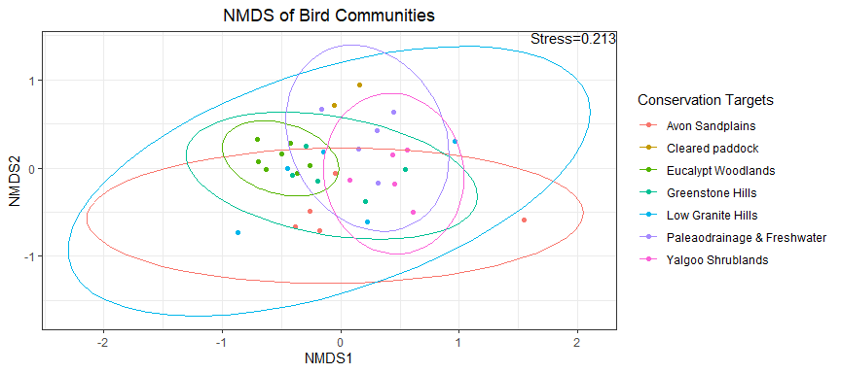

# Current Indicator values

## Diversity Estimates for Conservation Targets

Estimates of the number of species in the different Conservation Targets (Fig. 2 and Table 4), considering the total number of species, the number of species that are common, and the number of species that are very common (Species Richness, Shannon Diversity, and Simpson diversity, respectively). A low number of very common species could indicate over-abundant species dominating the community. Since each survey only detects a subset of the species present in the Conservation Targets, more robust estimates were calculated by pooling all sites and surveys for Conservation Targets in the last 5 years to encompass variation among years, increase sample sizes, and determine sample coverage (whether fewer or no new species are detected as more surveys are done). Estimates are incidence-based Hills diversity estimates with 95% confidence intervals (from iNEXT R package).

**Figure 2. Species diversity estimates for Conservation Targets.**

Plots show the number of species detected in Conservation Targets relative to the number of surveys, with the total number of species shown in orange (Species richness = q0), the number of common species in blue (Shannon Diversity = q1), and the number of very common species in purple (Simpson diversity = q2). Solid lines show observed estimates (rarefaction-based) based on the surveys that were conducted and dotted lines show estimates based on extrapolating to likely numbers if more surveys had been conducted. Extrapolated lines with little or no increase in the number of species indicate high sample coverage (few or no new species detected as more surveys are conducted). Shaded bands show confidence intervals for estimates - narrow bands indicate high confidence that estimates lie within a narrow range.

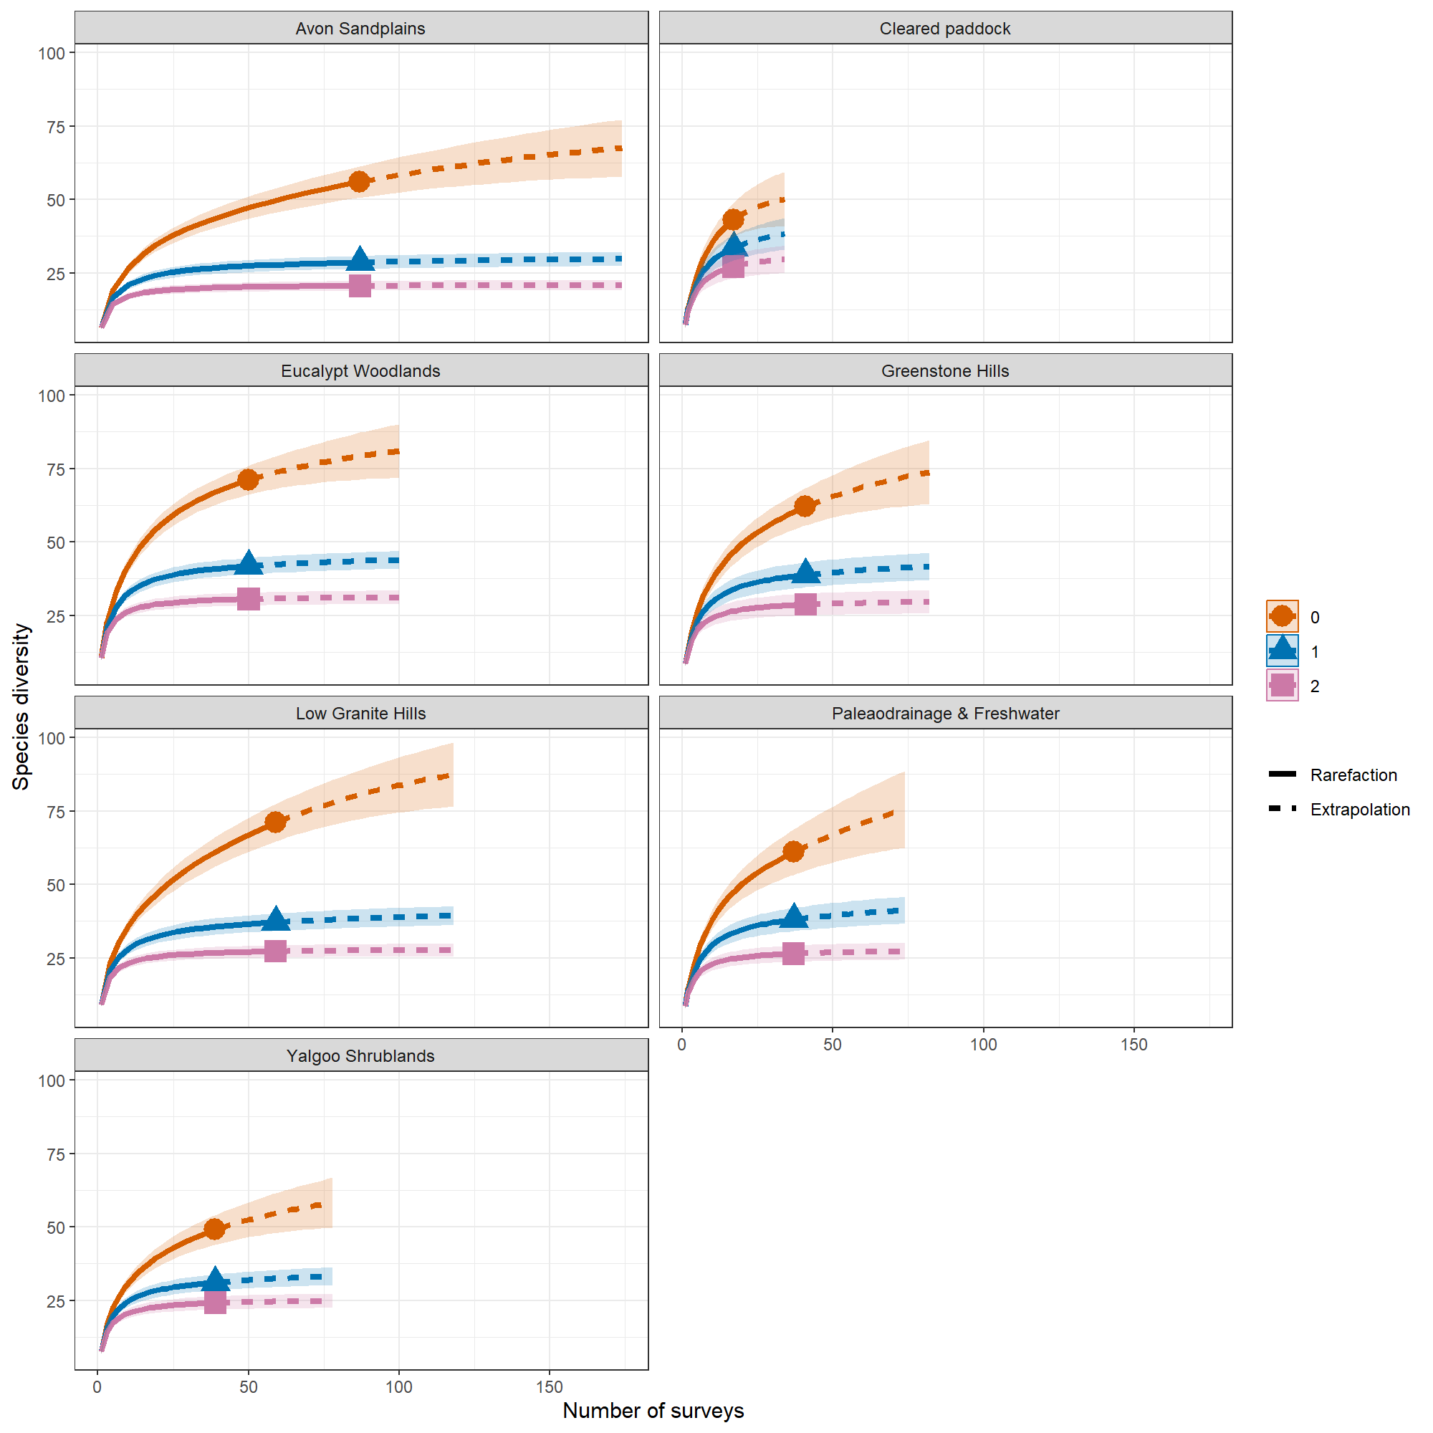

**Table 4. Species diversity estimates for Conservation Targets.** Observed values are the actual number of species detected in each category. Estimated values are estimates at the point where no new species are detected in new surveys (asymptotic estimates with standard error (s.e.) and lower and upper confidence intervals (95% probability that the actual value lies between LCL and UCL). Non-overlapping confidence intervals suggest evidence that estimates differ.

| Conservation Target | Diversity | Observed | Estimated | s.e. | LCL | UCL |
| --- | --- | --- | --- | --- | --- | --- |
| Avon Sandplains | Shannon diversity | 28.6 | 30.6 | 1.4 | 27.8 | 33.4 |
| Cleared paddock | Shannon diversity | 33.5 | 41.2 | 3.0 | 35.2 | 47.1 |
| Eucalypt Woodlands | Shannon diversity | 41.8 | 45.2 | 2.0 | 41.3 | 49.2 |
| Greenstone Hills | Shannon diversity | 38.8 | 43.5 | 2.2 | 39.3 | 47.8 |
| Low Granite Hills | Shannon diversity | 37.2 | 40.8 | 1.7 | 37.4 | 44.2 |
| Paleaodrainage & Freshwater | Shannon diversity | 38.1 | 43.9 | 2.3 | 39.3 | 48.4 |
| Yalgoo Shrublands | Shannon diversity | 31.1 | 34.6 | 2.0 | 30.7 | 38.6 |
| Avon Sandplains | Simpson diversity | 20.6 | 21.1 | 1.0 | 19.2 | 23.1 |
| Cleared paddock | Simpson diversity | 27.1 | 32.5 | 2.8 | 26.9 | 38.1 |
| Eucalypt Woodlands | Simpson diversity | 30.5 | 31.8 | 1.5 | 28.9 | 34.6 |
| Greenstone Hills | Simpson diversity | 28.7 | 30.4 | 1.7 | 27.2 | 33.7 |
| Low Granite Hills | Simpson diversity | 27.2 | 28.2 | 1.2 | 25.8 | 30.6 |
| Paleaodrainage & Freshwater | Simpson diversity | 26.4 | 28.0 | 1.5 | 25.1 | 31.0 |
| Yalgoo Shrublands | Simpson diversity | 24.1 | 25.6 | 1.5 | 22.6 | 28.5 |
| Avon Sandplains | Species richness | 56.0 | 76.4 | 27.7 | 56.0 | 130.7 |
| Cleared paddock | Species richness | 43.0 | 52.2 | 12.4 | 43.0 | 76.6 |
| Eucalypt Woodlands | Species richness | 71.0 | 86.7 | 10.8 | 71.0 | 107.9 |
| Greenstone Hills | Species richness | 62.0 | 81.8 | 12.4 | 62.0 | 106.0 |
| Low Granite Hills | Species richness | 71.0 | 98.9 | 17.6 | 71.0 | 133.4 |
| Paleaodrainage & Freshwater | Species richness | 61.0 | 96.1 | 17.8 | 61.2 | 131.0 |
| Yalgoo Shrublands | Species richness | 49.0 | 64.9 | 9.0 | 49.0 | 82.6 |

# Trends over time

Exploratory plots showing the number of species detected per survey across years, for all Conservation Targets. To formally evaluate trends over time, use statistical modelling to assess temporal change while simultaneously controlling for multiple other covariates (e.g. time of day etc, see below).

**Figure 3. Variation over time in number of species detected.**

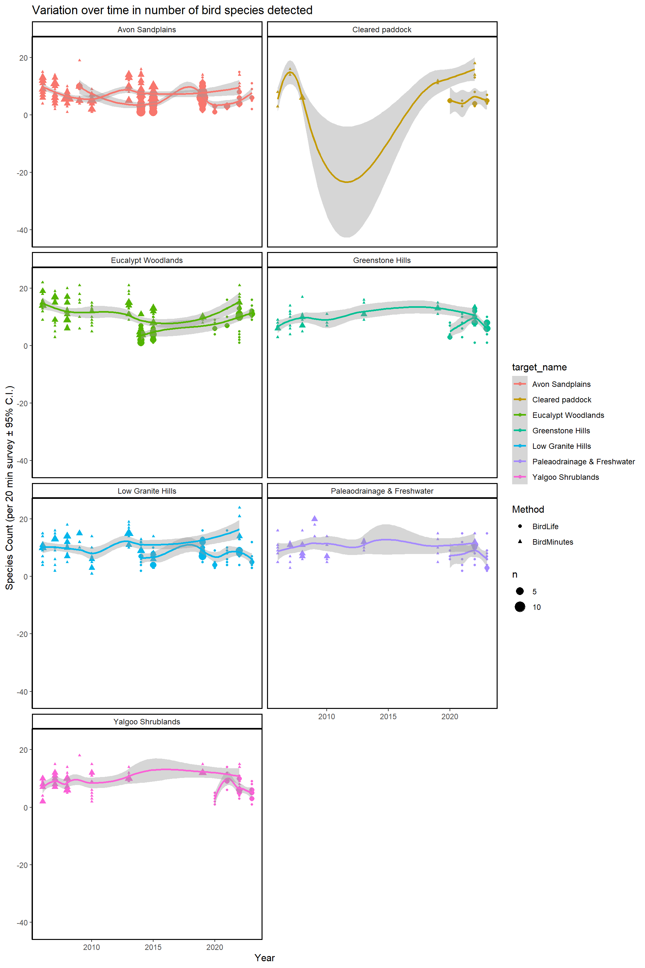

# Variability in bird surveys

Bird surveys are ‘snapshots’ that naturally give highly variable results depending on bird behaviour at the time, environmental conditions, observer experience, etc. A better understanding of drivers of this variability can help improve survey design and increasing sample sizes (number of sites and surveys) can give more robust estimates. These are descriptive exploratory plots. Some factors that can influence bird survey results are shown in Figure 4; temperature on the day and seasonal rainfall should also be considered.

**Figure 4. Some factors that may affect the number of bird species detected per survey.** Descriptive plots showing variation in the number of species detected per 20-minute survey associated with a variety of factors, based on all surveys that have been conducted at Charles Darwin Reserve. Each point shows the result of one survey. Boxes enclose the middle 50% of the data and the line within shows the mid-point (inter-quartile range and median respectively).

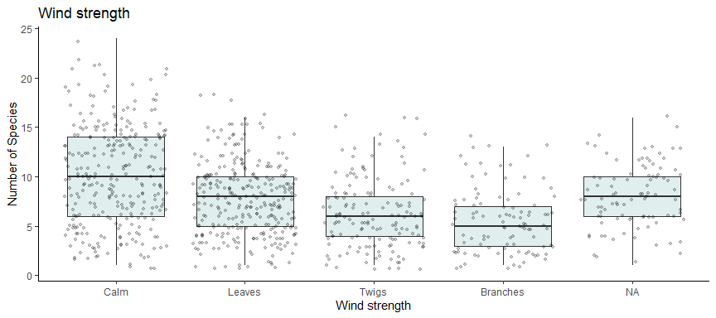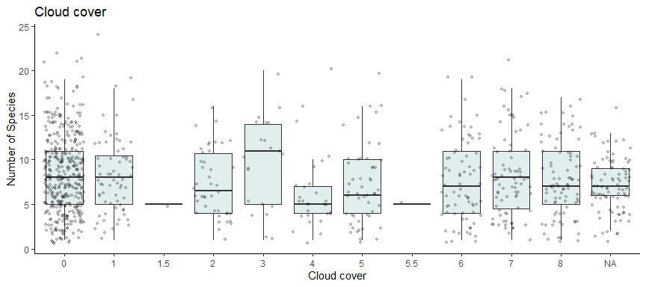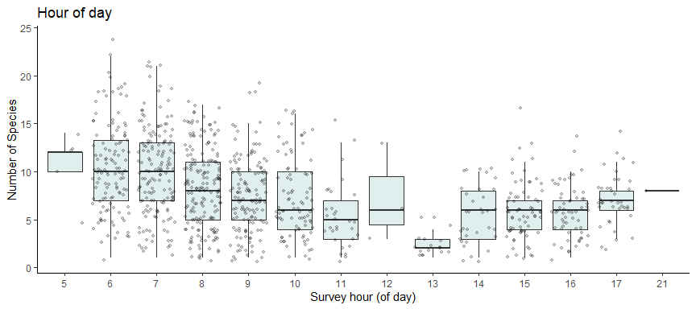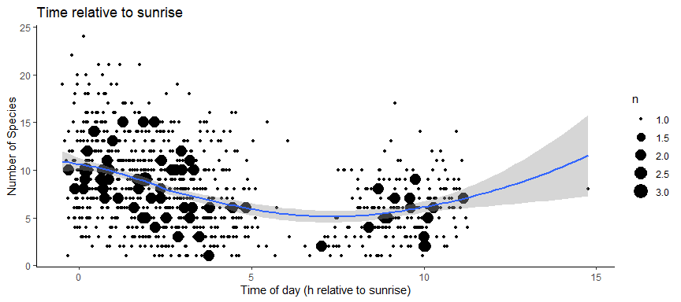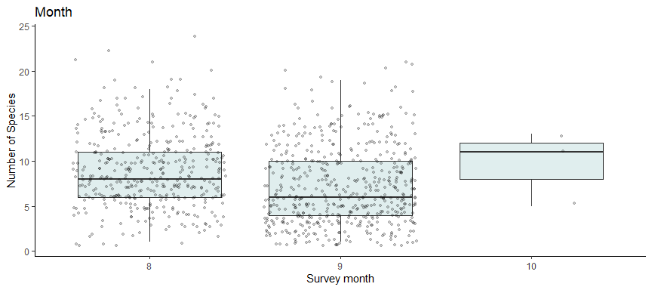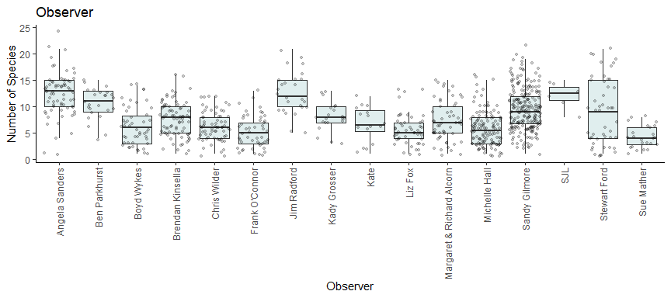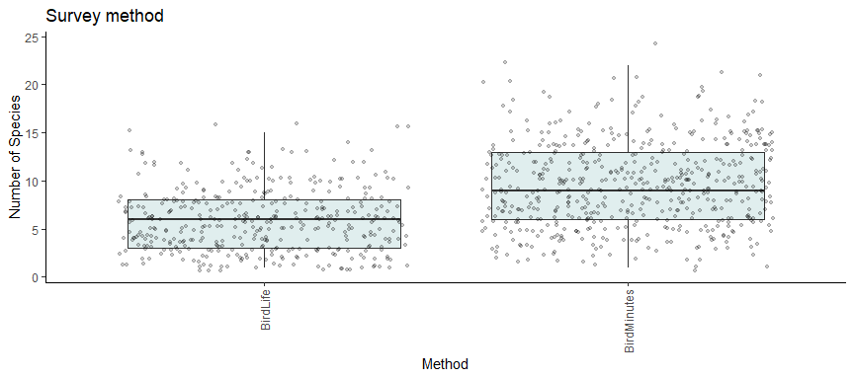

# Appendix